Birla Public School, Pilani
Subject: Computer Science (I.C.T)
Summer Holiday Assignment (2018-19)
Class: 10th
Q1. Create a Web Page Named simple-html-document.html.
- <html>
<head>
<title>First Document</title>
</head>
<body>
This is the my first Web page.
</body>
</html>
- Attribute:bgcolor=colorname
Eg:<body bgcolor=green>
- Attribute:background=”location of image/image_name. extension”
Eg:<body background=”C:\Users\BPS\Desktop\Dollarphotoclub_66314403comp.jpg”>
- Attribute:Alink,vlink,text
Eg: <body bgcolor=green alink=red vlink=blue text=yellow>

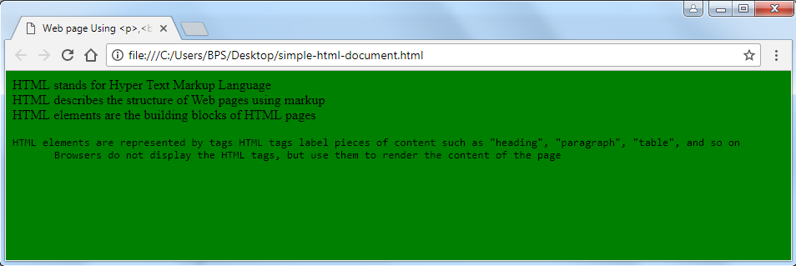
Q2. Create a Web page using following Elements/tags.
- <p> Tag
- <br> Tag
- <pre> Tag

Eg:
<html>
<head>
<title>Web page Using <p>,<br> and <pre> Tag</title>
</head>
<body bgcolor=green>
<p>HTML stands for Hyper Text Markup Language<br>
HTML describes the structure of Web pages using markup<br>
HTML elements are the building blocks of HTML pages<br>
<pre>HTML elements are represented by tags
HTML tags label pieces of content such as "heading", "paragraph", "table", and so on
Browsers do not display the HTML tags, but use them to render the content of the page</pre> </p> </body> </html>

Q3. Create a Web page using following elements/tags.
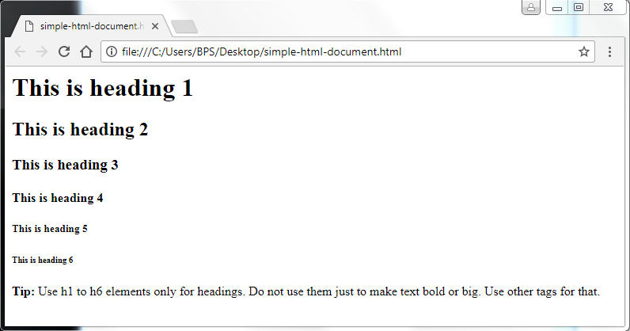
- Heading tags (H1,H2,H3,H4,H5,H6)
- Bold tag <B>

<html>
<body>

<h1>This is heading 1</h1>
<h2>This is heading 2</h2>
<h3>This is heading 3</h3>
<h4>This is heading 4</h4>
<h5>This is heading 5</h5>
<h6>This is heading 6</h6>
<p><b>Tip:</b> Use h1 to h6 elements only for headings. Do not use them just to make text bold or big. Use other tags for that.</p>

</body>
</html>

- Attributes of heading tags
Align=center, align=right, align=left, align=justify
Eg:<h1 align=right> This is heading 1</h1>
Eg:<h2 align=center>This is heading 2</h2>
Eg:<h3 align=justify>This is heading 3 </h3>
- Font tag and its attribute
Eg: <font> this is font element/tag. </font>
Attributes: size, color, and face
Eg: <font size=7 color=green face=”Times New Roman”>
This is font element and its attributes
</font>
Q4. Create a Web Page Named simple-web-page.html
<html>
<body>
<h2>The href Attribute</h2>
<p>HTML links are defined with the a tag. The link address is specified in the href attribute:</p>
<a href="https://www.w3schools.com">This is a link</a>
</body>
</html>
- Attributes: leftmargin, topmargin, and link
Example:<body background=”image.jpg” topmargin=90 leftmargin=85 link=#ff00ff text=green>
Q5. Create a web page named simple-img-tag.html
<html>
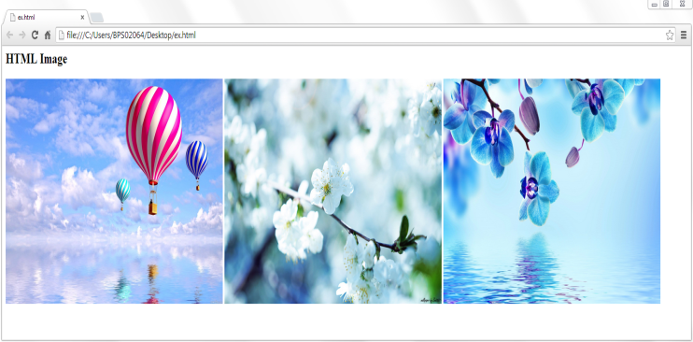
<body>
<h2>HTML Image</h2>
<img src="image1.jpg">
<img src="image2.jpg">
<img src="image3.jpg">
</body>
</html>
- Attributes:width, height, and alt
Example:<img src=”image1.jpg” alt=”this is first image” width="500" height="377">
Q6. Make a PowerPoint presentation on OneNote 365 and send on my gmail-ID btechengajeet@gmail.com
Q8. Create an Account on Microsoft office 365.

